STARAGILE JENKINS ASSIGNMENT -3

1. **Setup Jenkins on AWS Ubuntu Machine**

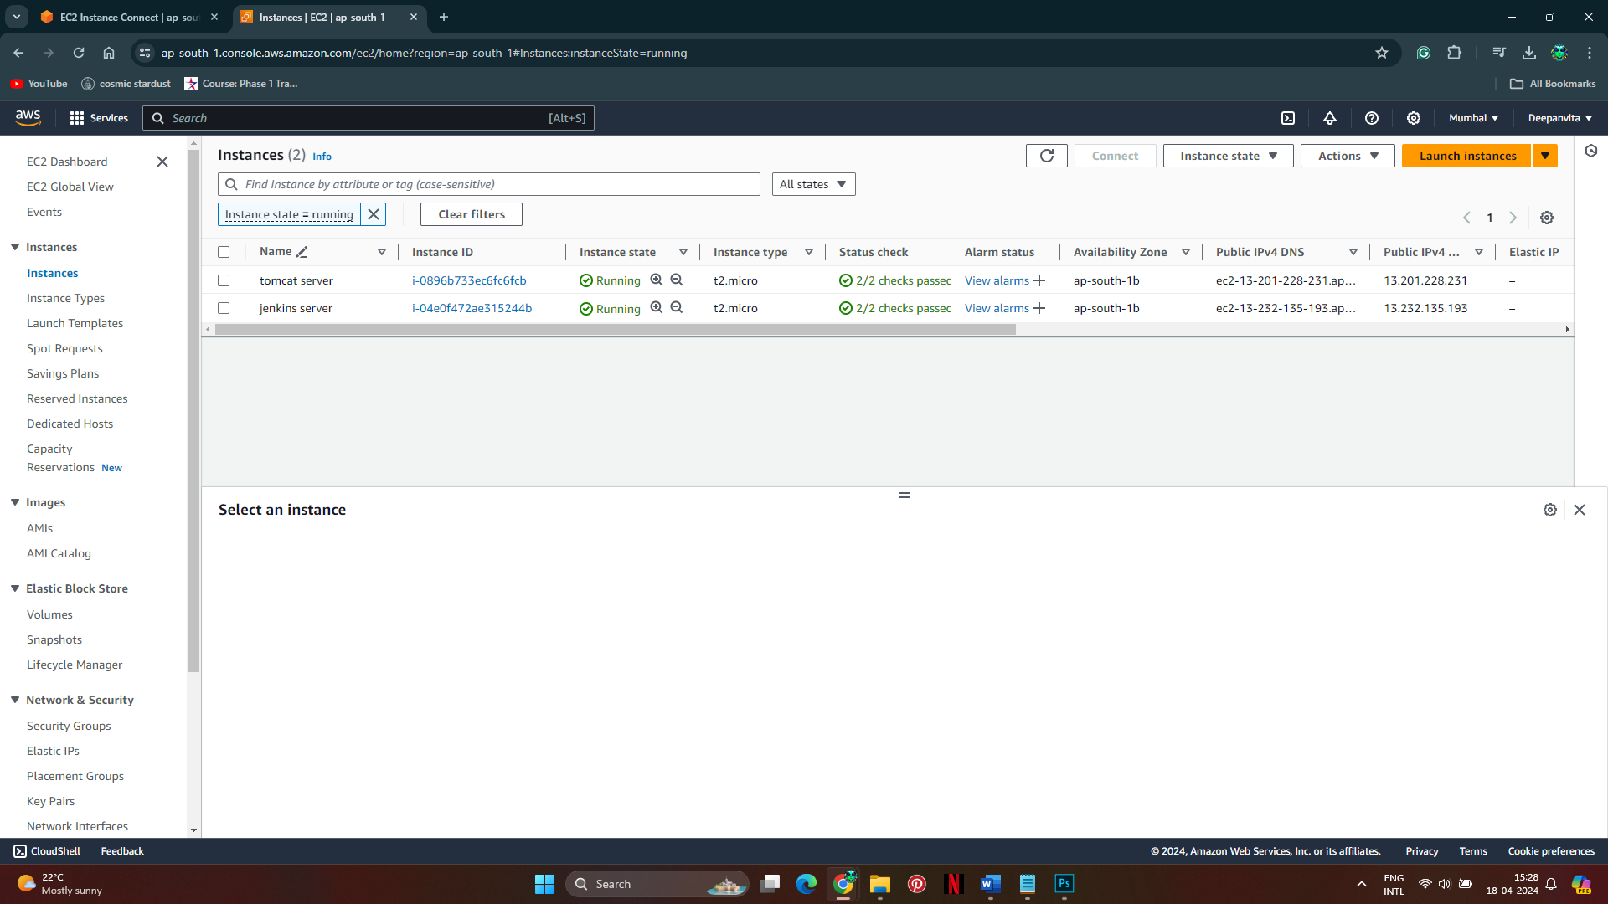

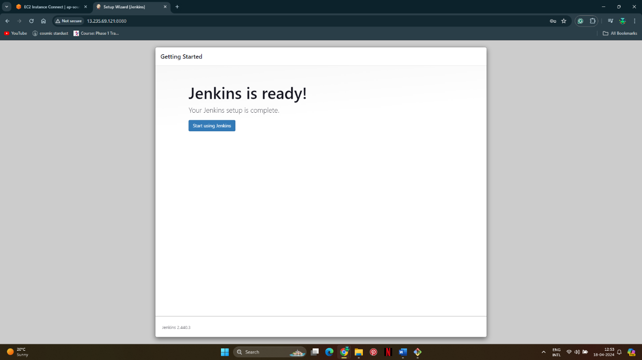

1. **Create a Pipeline Project**

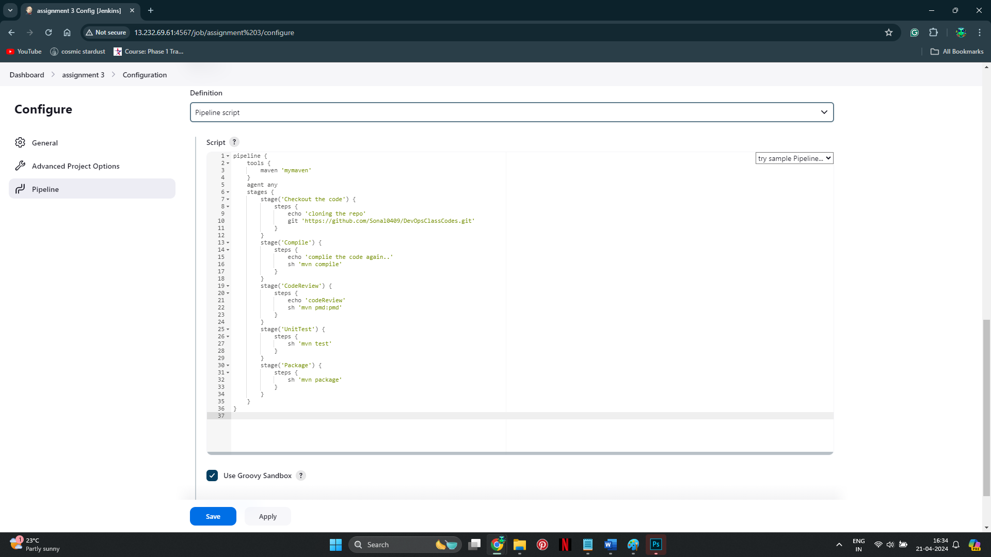

**3. Configure Git Repository**

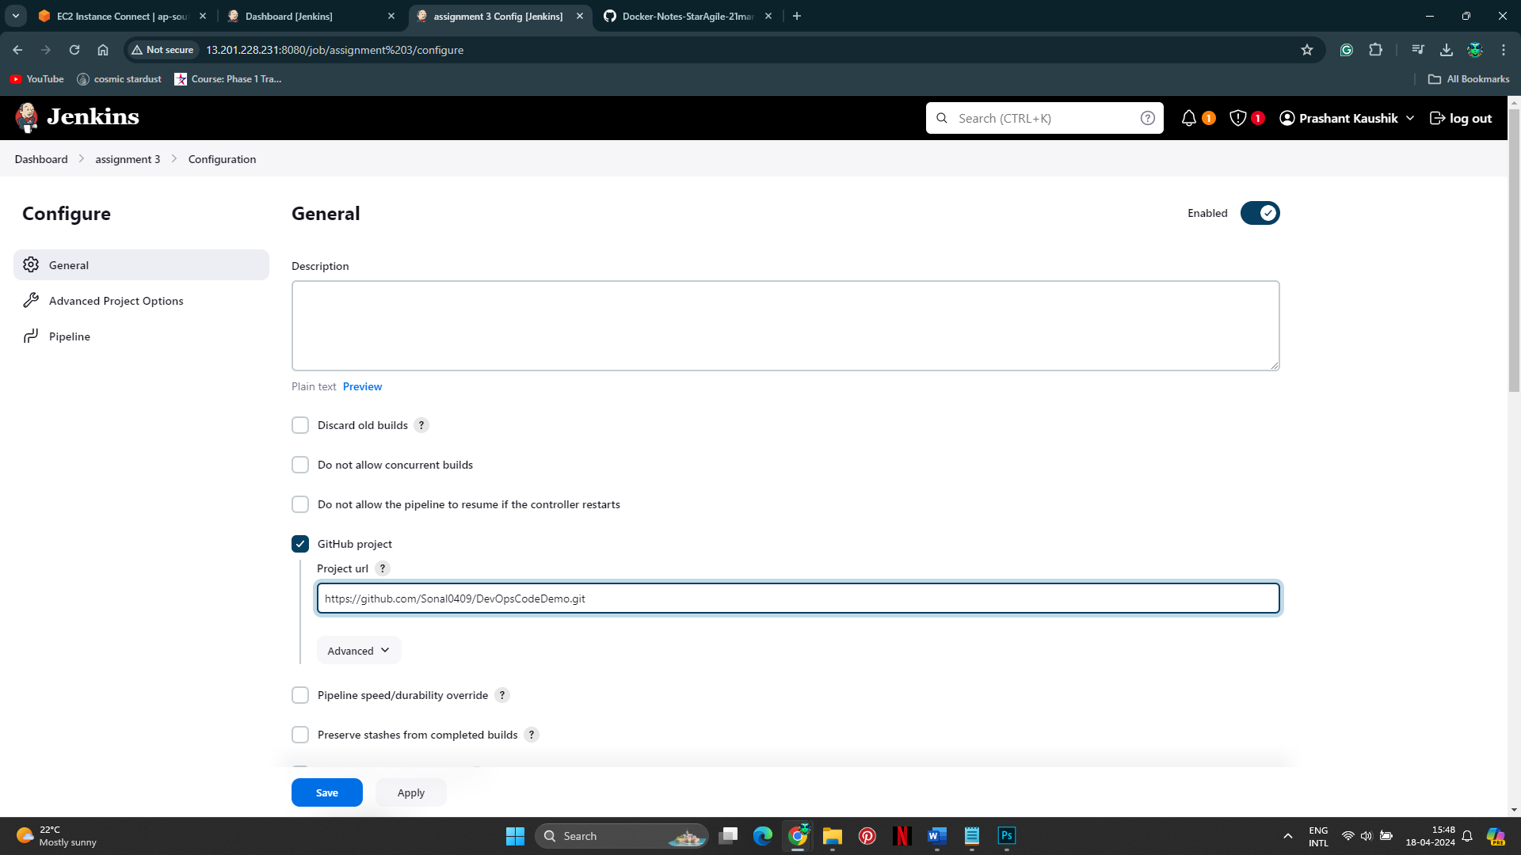

**4. Compile Source Code Using Maven**

**6. Package the Application as WAR**



**7. Install Tomcat9 Server on AWS Ubuntu Machine**



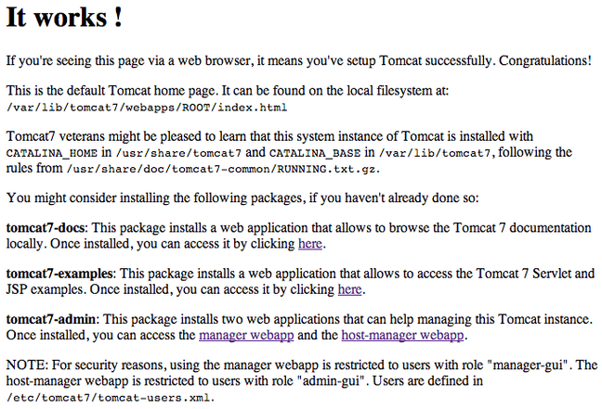

**8. Deploy the Packaged Application on Tomcat9**

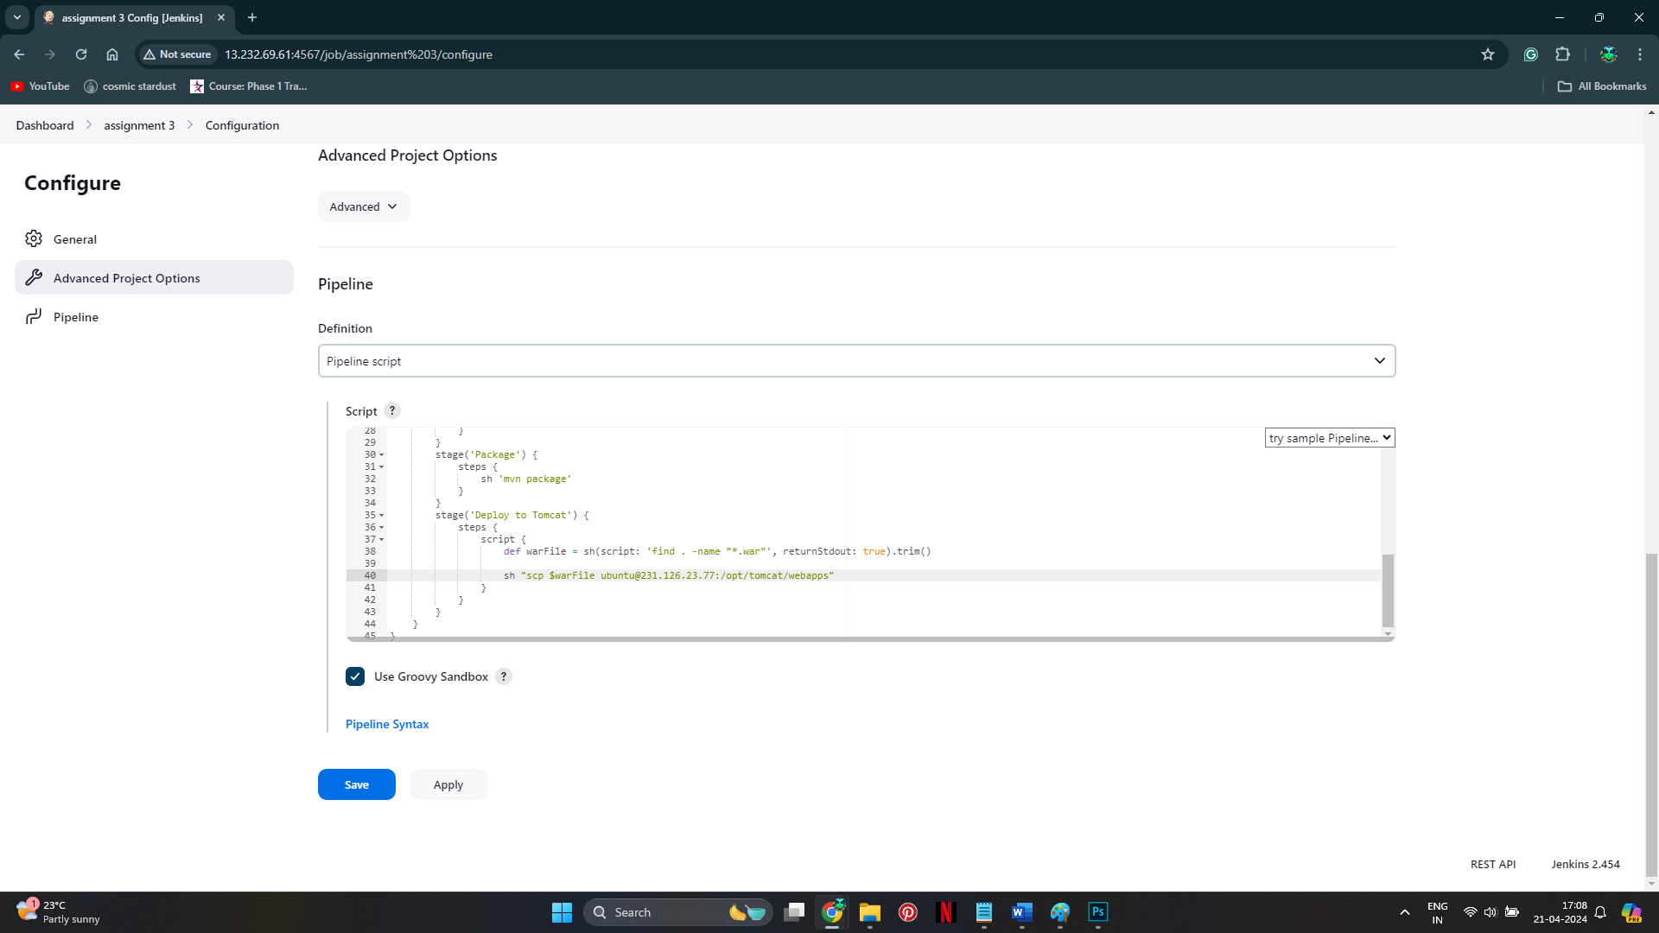

**Run the Pipeline**

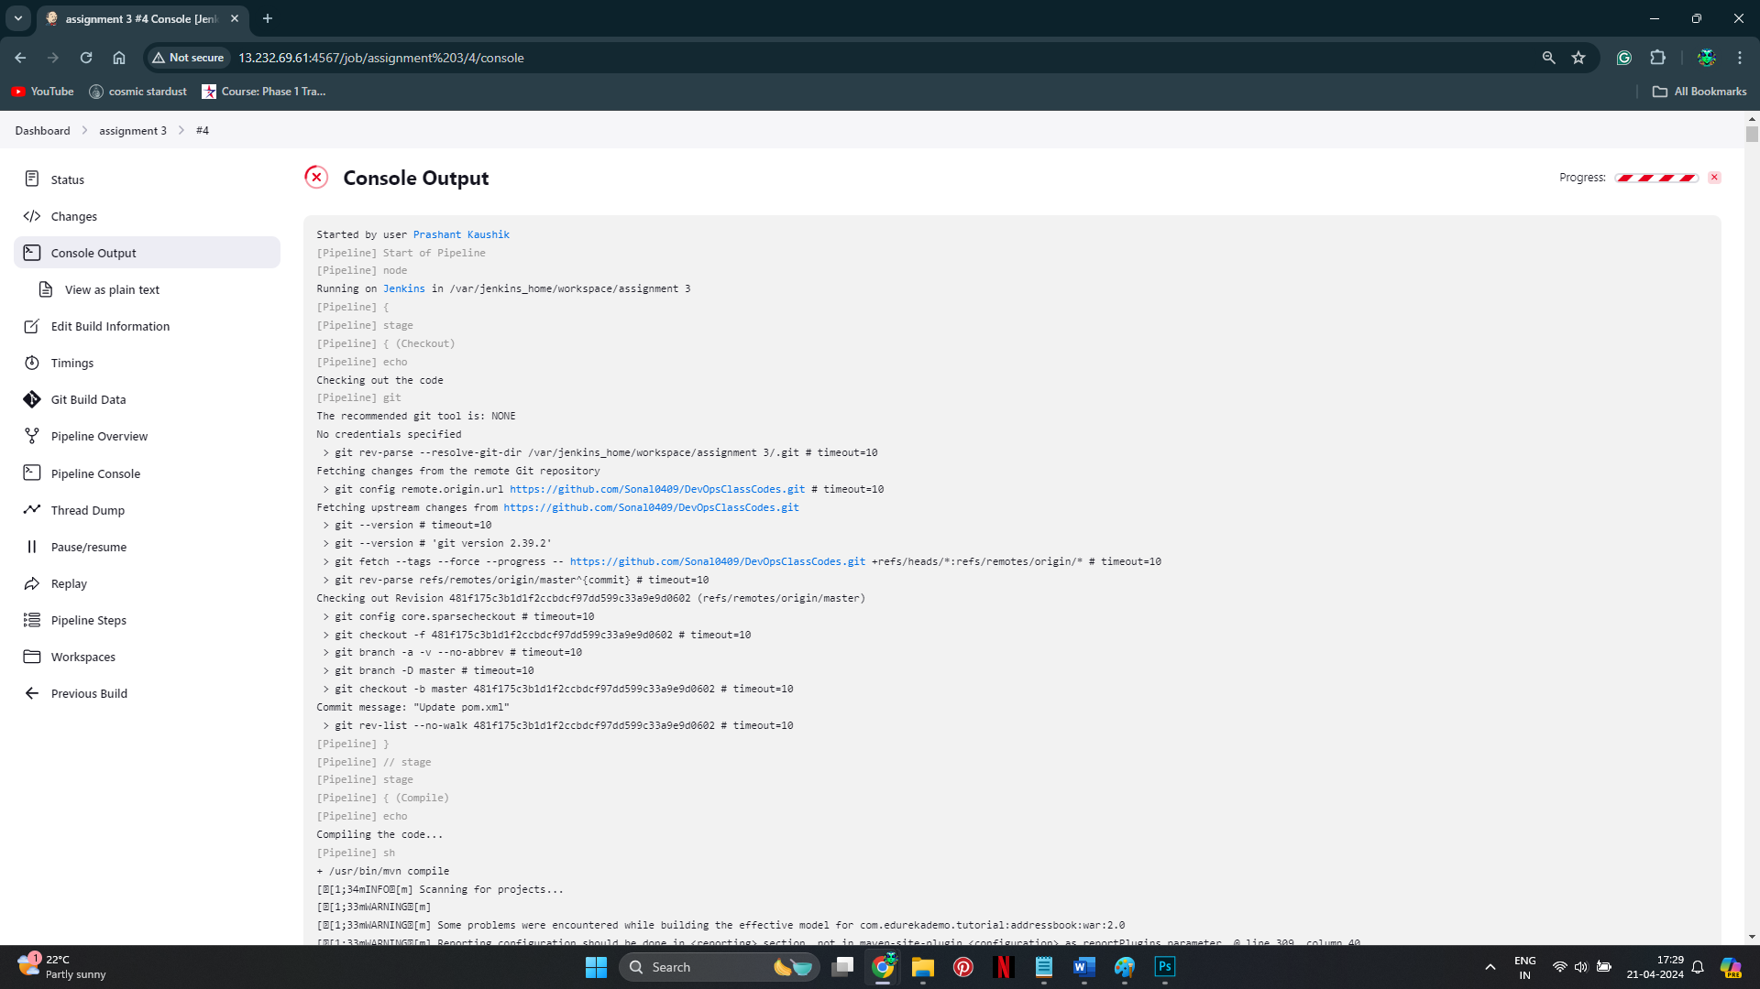

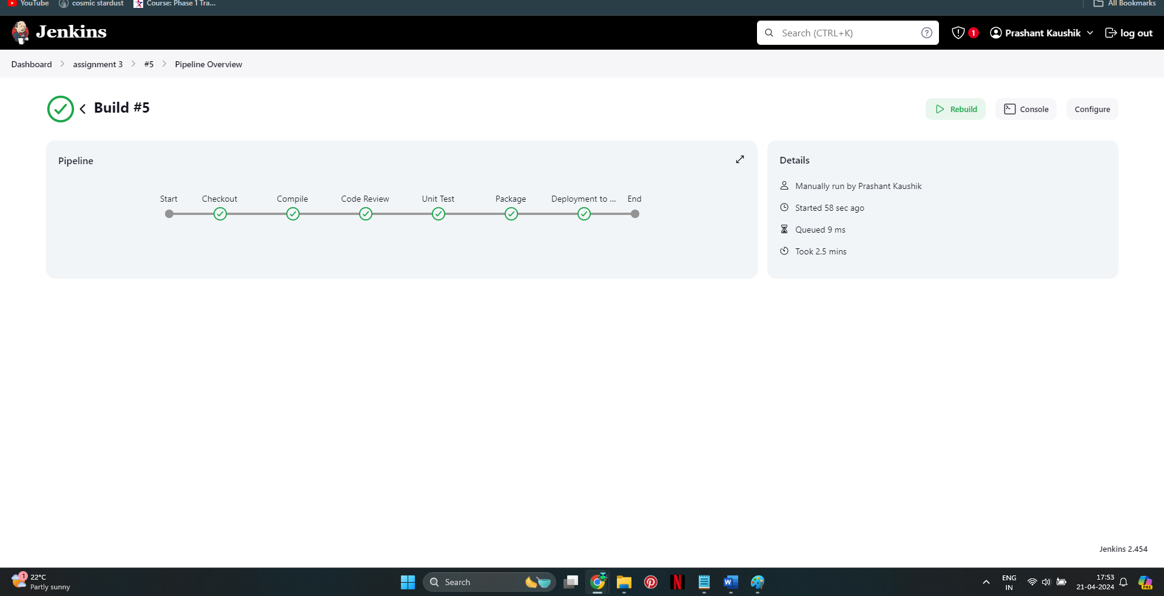

**9. Verify the Application**

